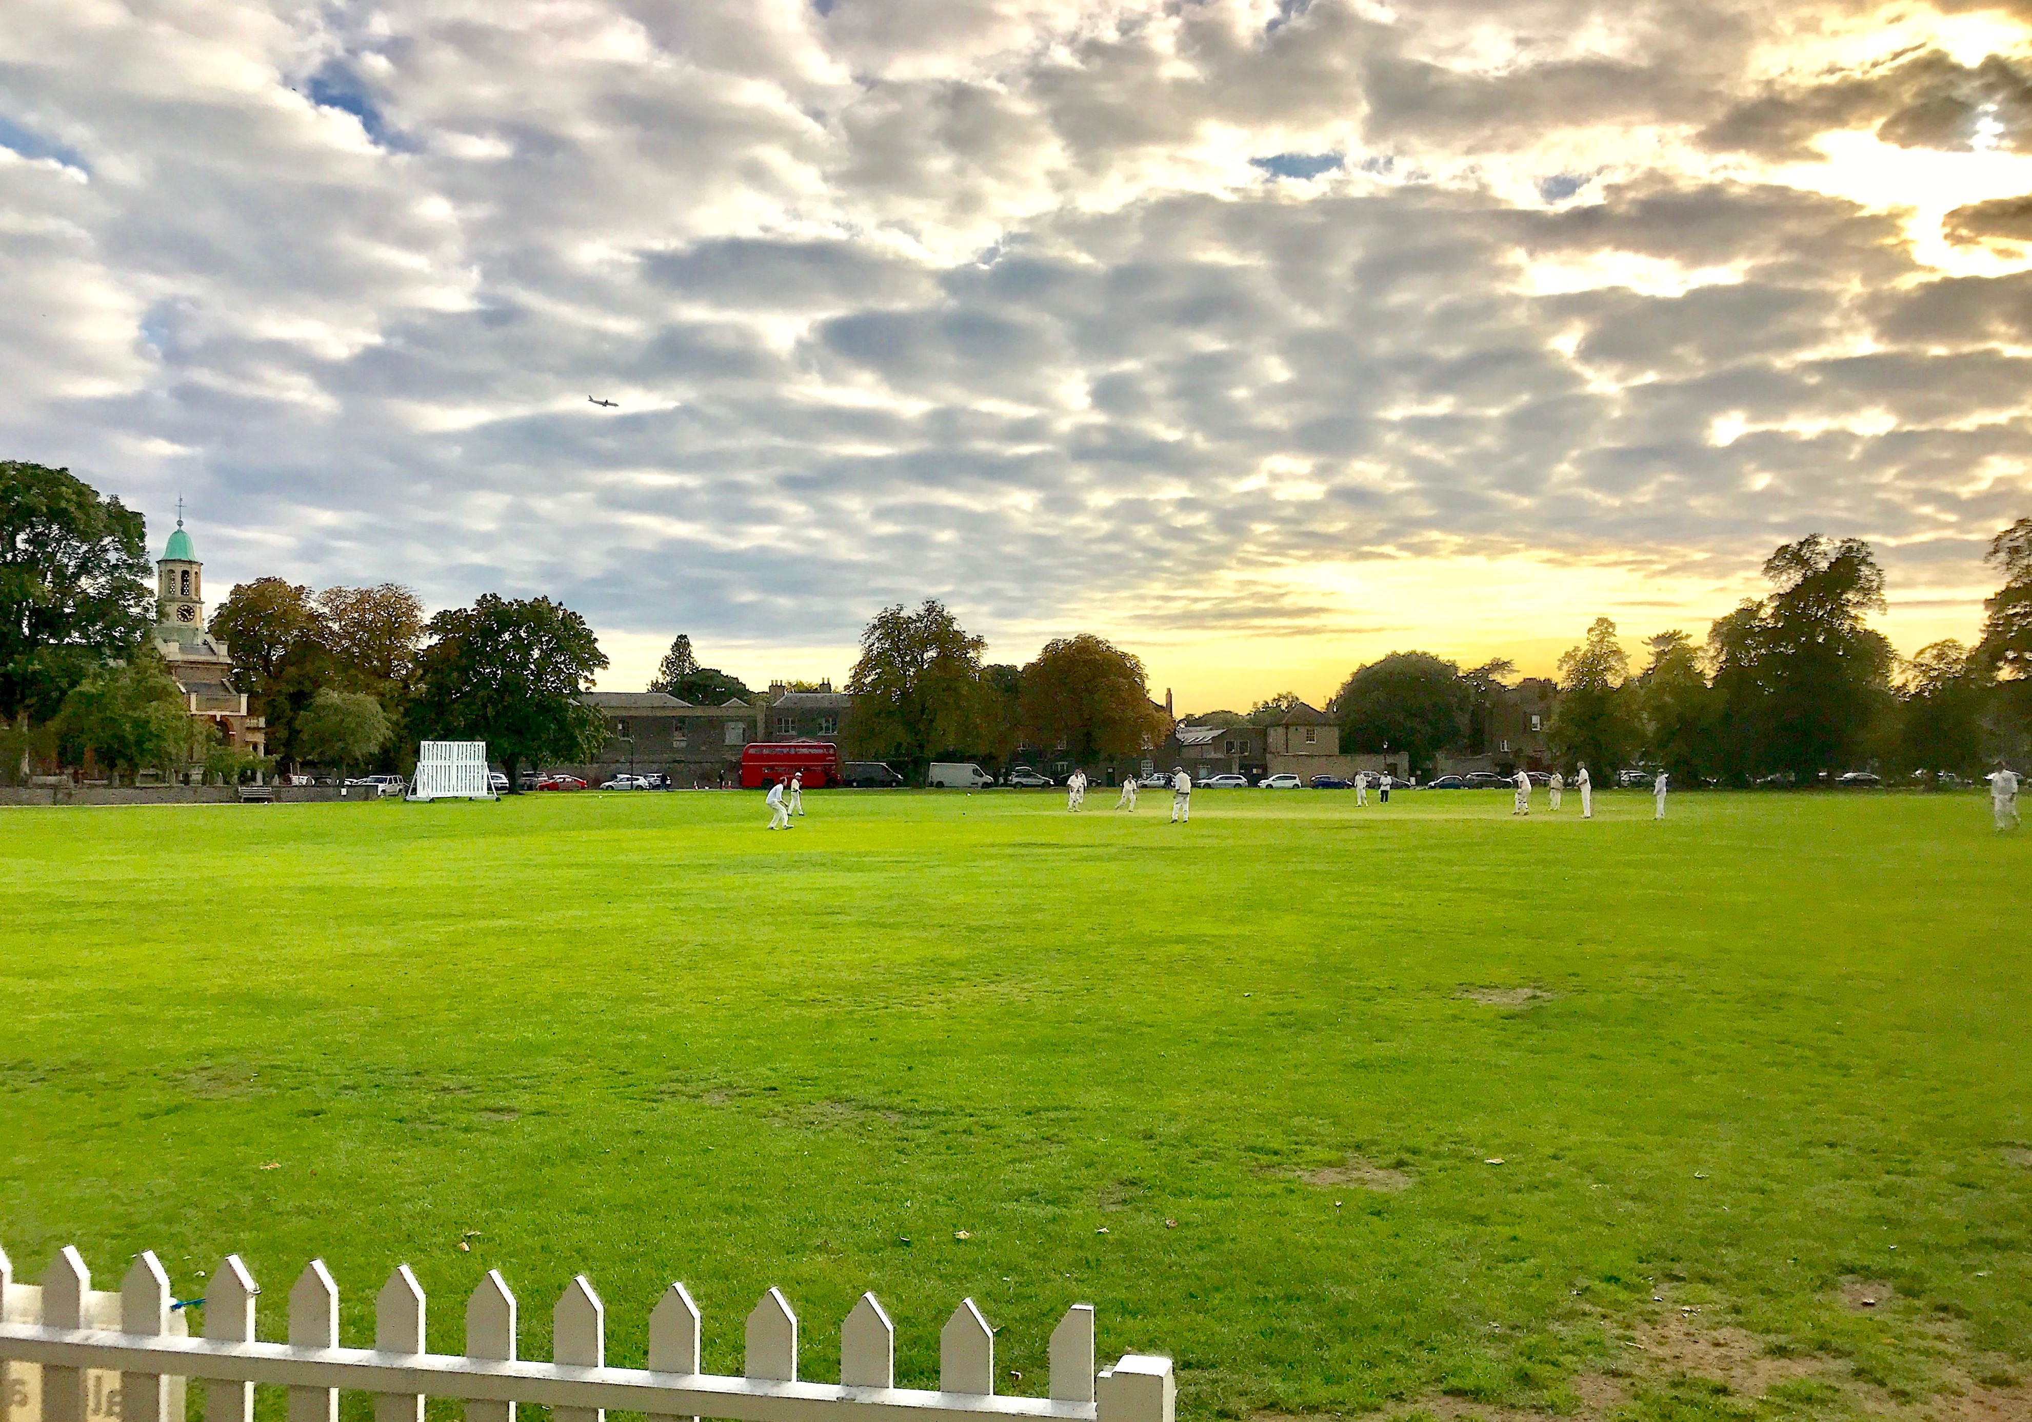

Dramatic skyline at Kew C.C. - Sept 23rd 2017

Because of the time of year, I unusually agreed to their skippers demands of a 40 over a side game. Nomads loss the toss and we were invited to bat.

The opening pair would be, not just any old Blackberry picker but a ''Sherfield on Loddon Blackberry picker', Steve Dummer and our dependable but today displaced wicketkeeper Saurabh Wahi. Steve played fluently unleashing a full array of shots around the wicket and Saurab batted sensibly setting a great platform for Nomads to make future assaults. (His time that morning in the Nets plus his 20 odd overs batting, possibly matches his previous batting time for the whole season.)

On the edge of Kew CC's ground stands St Anne's Church, Kew. Originally built in 1714, on land given by Queen Anne as a church within the then parish of Kingston.

By the Grace of God, King of Great Britain, France and Ireland, Defender of the Faith, Arch Treasurer and Prince-Elector of the Holy Roman Empire, Duke of Brunswick-Luneburg, George III, whom did receive on the steps of Kew Church news of Lord Charles Cornwallis's surrender at Yorktown and effectively the loss of the British American Colonies.

If George III had had the decency to wait some 230 odd years he could have received a message in leather from Steve Dummer who struck a mammoth exquisitely elegant straight six that sailed into that very Church yard. (Certainly a contender for shot of the season.)
Several notable persons have been buried at St. Anne's Kew and we hope no damage was inflicted by our Hampshire Hoodlum on Thomas Gainsborough's gravestone as the ball clattered about the churchyard.

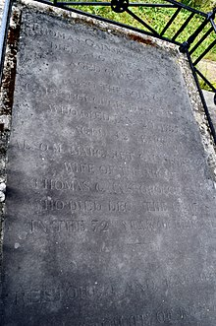

Gainsborough's Grave at St Anne's Church

This report is now beginning to remind me of MB's infamous Hampton Wick Royal C.C. Battle of Waterloo report but as a last incidental George III was also known as “farmer George,” a nickname redolent of his fellow sodbuster, George Washington. The King contributed articles to the “Annals of Agriculture” under the pen name Ralph Robinson, and favoured greatly Kew Botanical Gardens.

Back to cricket and I being an unselfish skipper decided to bat myself at 3 and Saurabh and I continued batting at a healthy rate taking the score at the 25 Over mark to 140 for 1. A 250 plus total was very much in our sights. The first three Nomad Batsman, Dummer, Wahi and Stokes scored strangely 47, 45 and 48 respectively - Collective Mass Jug Avoidance for sure. It was nice to see S Wahi bat so well in the dizzy heights of the top order, and I hope he gets more chances in the future.

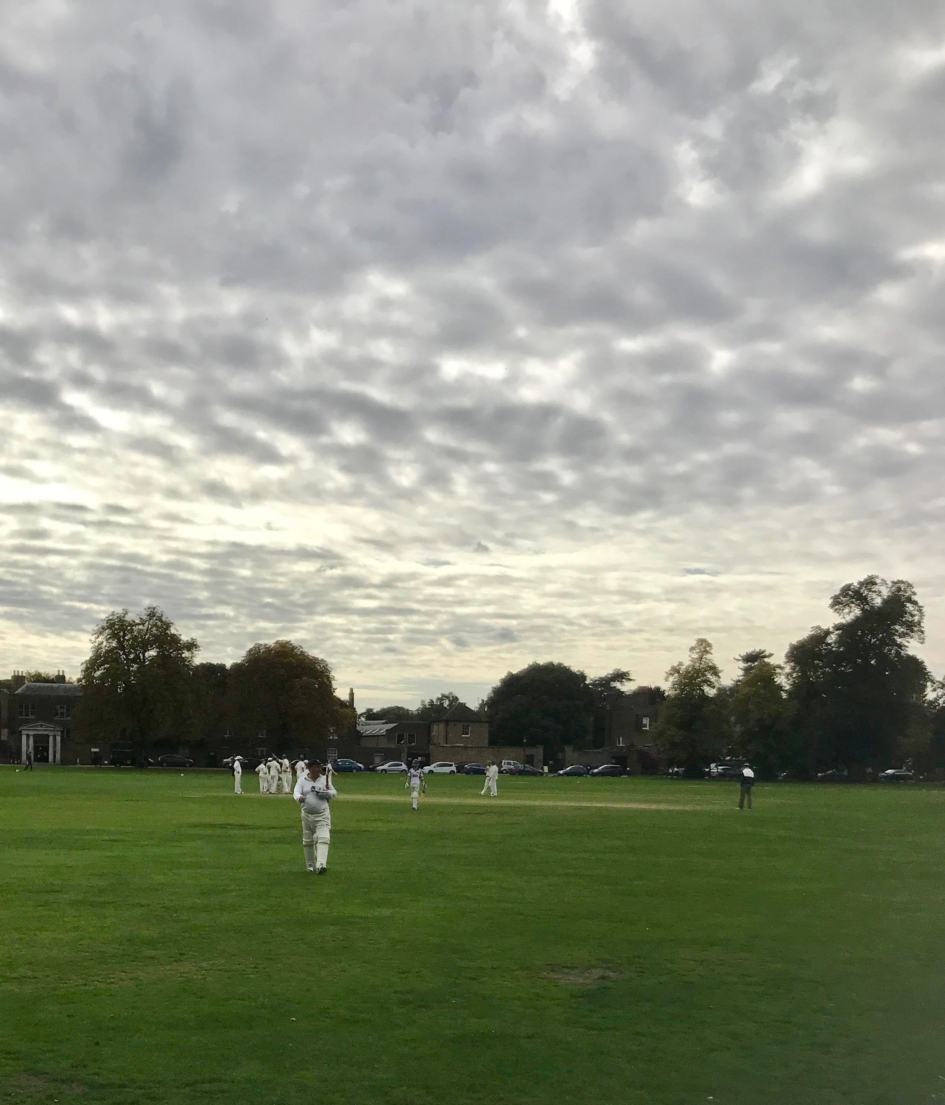

Skipper Stokes enjoyed batting with William Stokes
Until Andy was stupidly out for a rapid 48

It is reported that Princess Augusta, Princess of Wales in the late 1700's fed up with her dress getting muddy on the way to Church from nearby Kew Palace had the land that is now Kew CC extensively and extremely well drained. Kew cricketers claim it is the quickest drying ground in the country. It was certainly an extremely dry wicket for this time of year, and when Kew's spinners came on the ball turned appreciably completely changing the dynamics of the game. Runs were hard to come by, the boundary's dried up and the wickets fell. Tom Brockton (6) was Ct and Bowled by Malpass, (7-1-17-4) the pick of their bowlers. Rob Wycherley (19) then cruelly ran out 'No 1 Son' William Stokes (2).

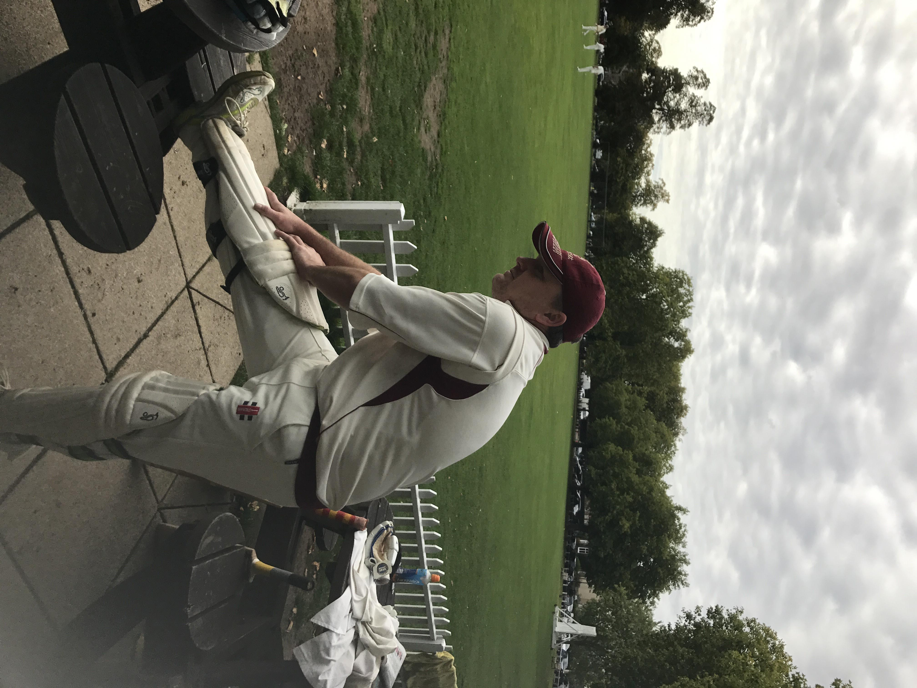

Rob W limbering up for some quick singles

Jake Vickers (0) was bowled for a duck, and it was left to Andy Marshall who looked comfortable and finished on 10* with Oliver Croom-Johnson (2) and Mike Robbins (0) to take Nomads to a final score of 190 all out off the penultimate ball of our allotted 40 Overs. Much less than earlier expected but a total to bowl to nevertheless. If you are wondering where our 11th man was then so were we, with a no show from Keith Juriansz.

Tea was taken and I reminded the lads of Thomas Gainsborough's great work 'Girl with Pigs' but this conjured up highly inappropriate thoughts in the ranks, and my own personal memories of the old Kew days with Russell Mann and Andy Weekes.
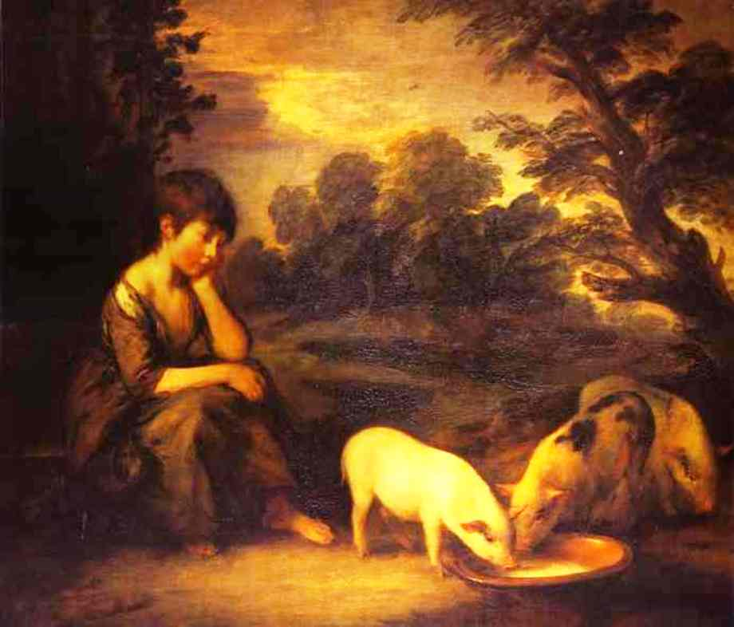

'Girl with Pigs' - Thomas Gainsborough 1782

As we took to the field I could hear whispers of words in the wind like, 'Andy Marshall' 'Andy Marshall' - 'this will be his wicket'. Mike Robbins over ruled the senior pro Oliver Croom-Johnson and opened the bowling from the preferred Church end, leaving the vetran to chug uphill into the wind from the Thames River end. Both bowled well but our lack of 11 men in the field cost us valuable runs.
It was great to see an old Virgin CC member affectionately known as 'Fat Sal' (Steve Vickers) who bought Nomads debutant young Jake Vickers to the game. Jake improved our ground fielding capabilities no end and took an important good catch at midwicket but more importantly bowled some very tidy off spin first change in tandem with the previous mentioned Mr Marshall. Jake picked up a couple of wickets, (8-1-44-2) and drew out one batsman very skilfully for Rob Wycherley to take a good quick stumping. Andrew Marshall proved that the whispers were indeed a correct foresight and he bowled amazing well returning figures of (8-3-11-2) which was a monumental achievement.

I asked Page what would have been the correct decision when the ball hit A Lutudi on the front pad his very first ball.

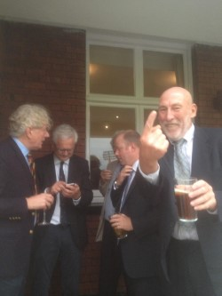

But others too had to perform and I had the problem of where to find the 5th bowler from. I forgot I can only bowl seam and chucked up some horrible filth in an attempt at off spin from the Church End, which very nearly cost us the game. A Stokes, (3-0-21-0), but I could have easily had a wicket off my first ball if our Club Captain hadn't been asleep at deep cover, if that had happened of Pages' bowling there would have been some choice words for sure.

Proving he is more than just a Blackberry Picker and a Batsman, Steve Dummer came to my rescue and bowled some very tidy off spin from the River end, picking up two much needed wickets (6-0-26-2).

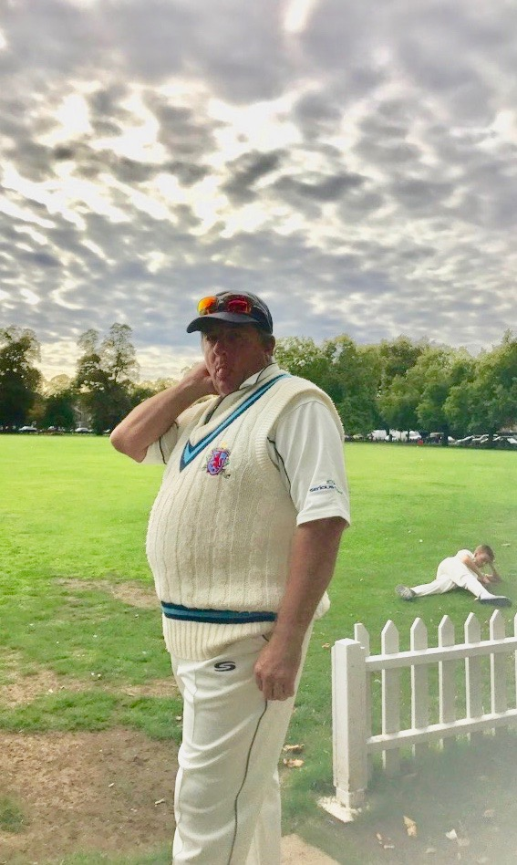

Both Batting and Bowling our Beloved Blackberry Bramble Barrelled Barbarian the Brutal Beautiful Buttery Basingstoke Boulder

Club Captain Tom gave sage advice throughout the day and when I acted on such and took myself off we were back in the game. Mike Robbins bowled a good second spell and then the old Croomer, Oliver C-J, (7-0-32-2) bowled a superb over on his return taking two wickets for 1 run at a critical point. Kew ticked the board over adequately we regularly took wickets and for a long period it looked like it was going to be a very close finish. So Mike Robbins, (8-1-41-0) who also took two good catches, returned for the 2nd time to bowl the last over from the previously unwanted River End. 9 runs required by Kew and just one wicket left. It transpired that at this end Mike bowled his best over of the day.

Mike hit a great line and full length and bowled the first 5 balls for just 3 runs leaving a 6 required for a tie off the last ball.
The last ball full and straight and just a single off it so a great Nomad win, especially in the 10-man circumstance, Kew 185 for 9. A Lutudi the pick of their batsmen 50*

Thanks to the photographers and to Emma and Leigh our lady supporters, thanks to William Stokes for stepping in for Mr Dean, thanks to Jake Vickers for making his Nomads debut and thanks to all 10 players for a good collective effort.
Apologies to Bill Rodwell that I left the second he literally stumbled in, I had a previously undercover covert meeting arranged across the road in the Greyhound Public House.

Thanks to Kew CC our hosts, we were very well looked after and enjoyed the day greatly.

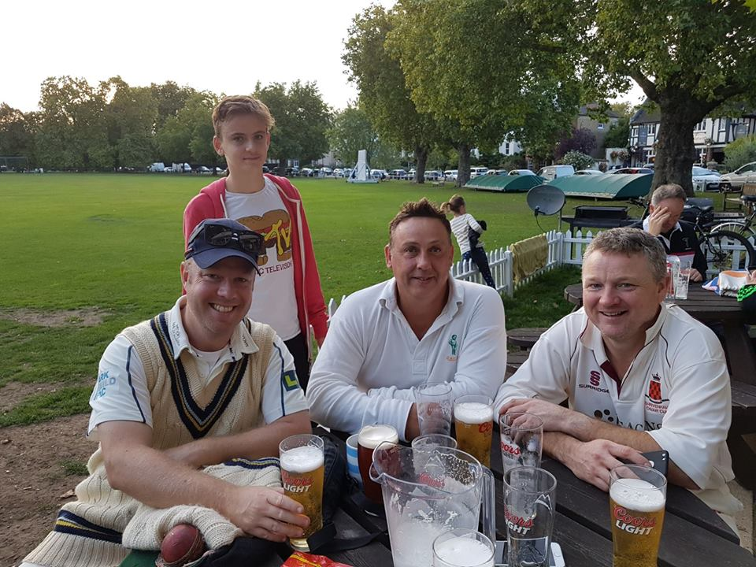

Plenty of Beers consumed on the day

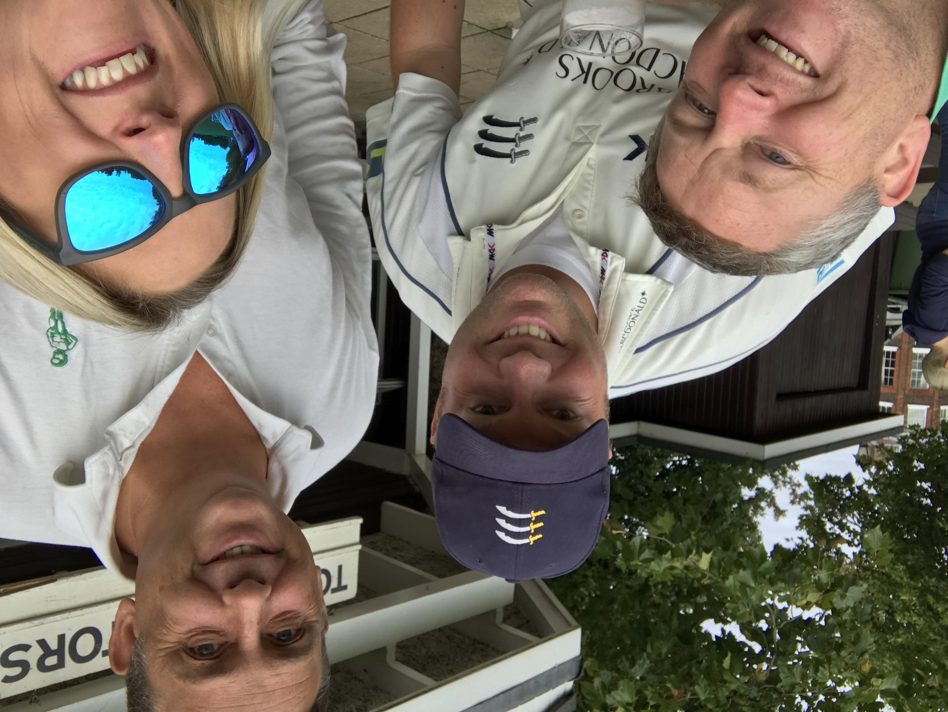

Nomads Version of 'Girl with Pigs' 2017

